Wild About Native Bees Day Camp

**Description:** Experience life as a native bee, in the Wild About Native Bees day camp. In this camp, youth will learn about native bees (hint: they are not the same as honey bees), and their importance as pollinators of food crops. Youth will explore the role of native bees as pollinators through modeling as they get food for themselves and their young while at the same time helping food crops produce fruit for us to eat. Youth will discuss challenges the native bees face and use a map to show how creating and preserving habitat can help native bee populations. Youth should leave the program understanding that without native bees and other pollinators, we wouldn’t have many of the foods we eat every day. Youth apply what they have learned and participate in citizen science by making bee nests to take home and observe.

**Background and Teen Leaders:** This camp is based on the 2019 National 4-H Council Ag Innovators Experience (AIE): Native Bee Challenge. Many of the activities are included in the “Facilitators’ Guide” from the 2019 AIE. The facilitators guide is available from this National 4-H website: <https://4-h.org/professionals/marketing-resources/ag-innovators-experience/> (you will need to log in to National 4-H to access the materials; anyone can create an account). The AIE workshops are facilitated by teen leaders that were trained to lead these activities. **It is highly recommended** that you include a teen leader for your camp. If trained teen leaders are utilized, kits with materials will be available to do the “Model of Pollination,” “Challenge Map,” and “Native Bee Nest” activities. To find a teen leader in your area and get the materials kit, contact Maya Hayslett, [hayslett@iastate.edu](mailto:hayslett@iastate.edu) or 319-321-1350. Materials for other activities are not provided. This camp can be led by any educator, using this curriculum; however, the materials for the activities will only be provided through the teen leaders. Additional teen leaders, and adults can be trained. Contact Maya Hayslett (contact information above) well in advance of the camp to arrange training.

**Materials Needed:**

* Kit for the Native Bee Challenge (materials needed can also be found in the Facilitators’ Guide and from the website if a kit is not available but will require additional materials and assembly)
* Teen Facilitator Guide for the Native Bee Challenge
* 2019 National 4-H Council Ag Innovators Experience website with Power Point and supplementary materials
* Copies of paper materials from the Teen Facilitator Guide and website as needed
* Computer, screen and projector for PowerPoint, websites, and videos (posters with the storyboard can be used instead but will require additional materials)
* Pens and/or pencils for collecting data and recording observations and reflections
* Some standard craft supplies (see last page for list)
* A sink if you choose to do the Bee Vision activity

**Grade Level**: 3rd–8th Grades (activities may be modified for younger or older age groups if needed).

**Facilities**: Location with adequate indoor work space with tables and an outdoor space for exploring nature.

**Facilitation**: With a group of 12 youth, it is recommended to have one adult facilitator and one teen leader (see background note above). Additional helpers such as older youth or adult volunteers would be beneficial.

**Preparation:** It is highly recommended that you read through the facilitator guide before leading the camp. The first part of the guide provides background information on native bee biology, challenges the native bees face, the importance of pollination for agriculture, the importance of biodiversity, and conservation strategies to help native bees and increase biodiversity. The rest of the guide has detailed instructions for leading the “Model of Pollination,” “Challenge Map,” and “Native Bee Nest” activities as well as directions for other supplemental activities.

**Evaluation:** This curriculum was developed for the 2019 National 4-H Council Ag Innovators Experience (AIE). We are expected to track and evaluate the program. Please ask youth to complete the “Participant Evaluation Sheet” and contact Maya Hayslett, [hayslett@iastate.edu](mailto:hayslett@iastate.edu) or 319-321-1350, to have them collected.

**Schedule**

|  |  |  |
| --- | --- | --- |
| **Time** | **Description and Resources** | **Supplies** |
| 9:00–9:30 | Welcome and Introductions, What is 4-H?, Logistics, Ice Breaker |  |
| 9:30–9:55 | **Activity**: What Is a Native Bee?  **Description**: This interactive presentation will use figures, discussion questions, and other tools to discuss with youth what makes an insect a bee, the biology of native bees, how native bees are different from honey bees, the importance of native bees for pollination, and how native bees are in danger.  **Instructions**: Go through PowerPoint from the website, asking discussion questions and doing activities as directed. | **From website:**   * PowerPoint * Discussion questions |
| 9:55–10:15 | **Activity:** Flower Dissection  **Description**: To better understand how pollination works, dissect a real flower to see the reproductive system. Use this lesson from Oregon State University to guide youth through the dissection. <https://lpi.oregonstate.edu/sites/lpi.oregonstate.edu/files/pdf/hyp/lessons-manuals/K12/K5/grade_two_flower_dissection4-2-2016.pdf>  **Instructions**: Follow the instructions from “Part 1. Bees at a Produce Farm” in the Teen Facilitator Guide. The flower cards and bee cards need to be available for each group. | **Per group of 12**  **Not in the kit:**   * 12 fresh flowers, daffodils, and lilies work well * 12 magnifying lenses (or at least 1 per group of 4) * Parts of a flower diagram (1 per group) * 12 pieces of paper * 12 cotton swabs * 12 pens or pencils * Optional: 12 tweezers to help pull apart the flowers * Optional: FOR ADULT USE ONLY — a craft knife to cut open flowers |
| 10:15–10:55 | **Activity:** Model of Pollination  **Description**: In the “Model of Pollination” activity, youth use a model to investigate how bees both get food from flowers and pollinate flowers. Youth experience the model as different species of native bees trying to gather food and bring it back to their nest. Models of flower parts will be used to simulate what bees experience. Time for reflection is included. The flower model must be prepared in advance.  **Instructions**: Follow the instructions from “Model of Pollination” in the Teen Facilitator Guide. The flower cards and bee cards need to be available for each group. | **Per group of 12**  **From the kit (or make from facilitator guide and website):**   * 9 flower cards and flower part models (already assembled) * 15 Bee cards and bee spoons (already assembled) — 3 of each species * 9 colors of sequins * 12 cups or toilet paper rolls * Optional: craft paper to make nest divisions |
| 10:55–11:05 | **Break/Snack** |  |
| 11:05–11:25 | **Activity:** Flower and Bee Morphology  **Description:** The focus of this activity is the concept of co-evolution, specifically the relationship between flower structure and the  length of a bee’s tongue.  **Instructions:** Follow the directions for the “Flower and Bee Morphology” activity in the Teen Facilitator Guide. Models need to be made in advance. | **Per group of 12**  **Not in the kit:**   * 12 pieces of construction paper * Tape * Two colors of small (1/4-inch) craft pomp oms, about 1 cup of each * 12 Straws * 12 pieces of Velcro (small, to fit on the end of the straw) |
| 11:25–12:00 | **Activity:** Nature Walk (Reflection Time)  **Description:** Think about habitat for native bees and gain appreciation for nature with a short walk. Collect a few items if you plan to do the bee vision craft.  **Instructions:** Take youth for a walk nearby. Natural areas, parks, or any place outside will work. Encourage youth to make observations as they walk. What kinds of plants and animals do you see? Is there any habitat for bees (flowers)? Look at the flowers. Can you see the anthers with pollen? What do you enjoy about nature or being outside? Youth can use magnifying glasses to look closely at flowers and insects. Youth can also look for and identify pollinators using one of these guides: <https://www.buglife.org.uk/sites/default/files/Pollinator%20identification%20chart.pdf> or <https://www.extension.umn.edu/garden/yard-garden/flowers-for-pollinators/docs/pollinator-guide.pdf> | **Optional:**   * Printed pollinator identification guides (see websites) * Magnifying glasses |
| 12:00–12:30 | Lunch |  |
| 12:30–1:00 | **Activity**: Bee Craft  **Description**: Learn more about bees by making a craft.  **Instructions**: Choose one of three crafts. Directions are on the following pages.   1. Bee Vision: Youth learn about UV light and how bees see, while creating take-home art (any age group). 2. Bee Anatomy: Youth learn about bee body parts by creating a model of a native bee out of craft items (better for younger youth). 3. Bee Origami: Youth learn about bee parts while creating an origami bee (better for older youth, requires fine motor skills and following complex directions). | **Not in the kit:**   * See supplies list on the following pages |
| 1:00–1:30 | **Activity**: Map Challenge  **Description**: Youth apply what they have learned. A final challenge asks youth to take the role of different members of the community trying to increase biodiversity and habitat for bees. Youth place icons on a map to show where the bees are and where more habitat can be added. They then share and defend their placement (includes questions for reflection).  **Instructions**: Follow the instructions from “Challenge Map” in the Teen Facilitator Guide. | **Per Group of 4**  **From the kit:**   * 1 challenge map * 1 set of magnetic icons * 1 set of bee cards * 1 table of icon descriptions * 1 map key * 37 bee bucks |
| 1:30–1:40 | **Activity**: Slicing Up Earth’s Land Resources  **Description**: Have apples for snack time while you use an apple to show how land for food production is a limited resource.  **Instructions**: Follow the instructions for “Activity 1: Slicing Up Earth’s Land Resources” from the lesson “How Much Is Dirt Worth?” from the Iowa Ag Literacy Foundation website <https://www.agclassroom.org/iowa/matrix/lessonplan.cfm?lpid=148>. | **Per youth**  **Not in the kit:**   * 1 apple for snack   **For leader demonstration:**   * 1 apple * Knife and cutting board |
| 1:40–2:00 | **Activity**: Citizen Science  **Description**: Watch videos to learn about citizen science. Discuss opportunities to monitor bees in Iowa.  **Instructions**: Watch these two videos about how people can help scientists learn more about bees. <https://www.youtube.com/watch?v=6LCFP2eqPPc>  <https://www.youtube.com/watch?v=rsMe5PZMSz8>  Discussion questions: Why is it important to learn more about native bees? What do we need to know? Can anyone help? How can you help? |  |
| 2:00–2:30 | **Activity**: Native Bee Nests  **Description**: Youth can apply what they have learned by making a bee nest to take home and observe.  **Instructions**: Follow the directions from the facilitators’ guide to assemble the nests. Go to the Crown Bees website, for this activity, and go over directions for placing the sticker, where to place the nests, and how to track bee activity using the website. Gather a few small sticks and twigs before-hand. | **For each youth**  **From the kit:**   * A pre-cut PVC pipe (see guide for dimensions) * A PVC pipe endcap to fit one end * 14 nest tubes (paper straws to fit snugly inside PVC pipe) * A small amount of clay * 1 rubber band * Small sticks to put between spaces (not in kit) * 1 large zip tie * Citizen science label |
| 2:30–2:45 | **Activity:** Beach Ball Pollination  **Description:** Youth will review how bees pollinate flowers with a fun active game.me helps youth understand thaat t pollen is the winner.c eggs (think easter egg hunt). Youth should collect as muchhoose the r  **Instructions:** Visit this website to download the PDF and view the directions. Lesson from Story County Conservation. You can skip the introduction since you have already covered pollination information. Go directly to the directions. You may wish to do one, two, or all three rounds described in the directions, depending on how much time you have left at the end of the day. <https://www.google.com/url?sa=t&rct=j&q=&esrc=s&source=web&cd=1&ved=2ahUKEwiAgoP8lcvgAhUHs54KHVWeBs0QFjAAegQIChAC&url=http%3A%2F%2Fwww.teachers-going-green.com%2F_literature_135954%2FBeach_Ball_Bee_Pollination_Game_Lesson-3rd_Grade&usg=AOvVaw0JcQI8cJj3jX8o5NaDtUkI> | **Per group of 12**  **Not in the kit:**   * 2 inflated beach balls * 4 different colors of Post-it notes, about 20 of each |
| 2:45–3:00 | Recap and Reflections for the Day, Survey |  |
| 3:00–3:30 | Showcase for Parents/Guardians:   * Welcome and Introductions * Overview of Day * Youth Reflections and Sharing |  |

Wild About Native Bees Day Camp: Supply list per group of 12 youth participants

# Kit Contents

|  |  |  |
| --- | --- | --- |
| **Quantity** | **Item** | **Activity** |
| 9 | Flower part models | Model of Pollination |
| 9 | Flower cards | Model of Pollination |
| 15 | Bee models | Model of Pollination |
| 15 | Bee cards | Model of Pollination |
| 9 | Cups of sequins (9 colors) | Model of Pollination |
| 12 | Toilet paper rolls | Model of Pollination |
| 1 | Challenge map | Challenge Map |
| 1 | Set of magnetic icons | Challenge Map |
| 1 | Table of icon descriptions | Challenge Map |
| 1 | Map key | Challenge Map |
| 37 | Bee bucks | Challenge Map |
| 12 | Pre-cut PVC pipes | Native Bee Nest |
| 12 | PVC pipe endcaps | Native Bee Nest |
| 168 | Paper nest tubes | Native Bee Nest |
| 1 | Block of clay to share | Native Bee Nest |
| 12 | Rubber bands | Native Bee Nest |
| 12 | 11” zip ties | Native Bee Nest |
| 12 | Crown Bee stickers | Native Bee Nest |

# Other Supplies Needed (not including optional supplies and printed items, starred items may be brought from home or the office)

|  |  |  |  |
| --- | --- | --- | --- |
| **Quantity** | **Item** | **Activity** | **Estimated Cost** |
| 12 | Fresh flowers, daffodils, and lilies work well | Flower Dissection | $10 |
| 12 | Magnifying lenses | Flower Dissection | $12 |
| 12 | Pieces of paper | Flower Dissection | $1* |
| 12 | Cotton swabs | Flower dissection | $5* |
| 12 | Pens or pencils | Multiple activities | $3* |
| 12 | Apples | Slicing Up Earth’s Land | $10 |
| 1 | Knife and cutting board | Slicing Up Earth’s Land | $15* |
| 12 | Pieces of construction paper | Flower and Bee Morphology | $5* |
| 1 | Roll of tape | Flower and Bee Morphology | $1* |
| 2 | Colors of small (1/4-inch) craft pomp oms, about 1 cup of each | Flower and Bee Morphology | $5 |
| 12 | Straws | Flower and Bee Morphology | $2 |
| 12 | Pieces of Velcro | Flower and Bee Morphology | $3 |
| 2 | Beach balls | Beach Ball Pollination | $2 |
| 4 | Colors of Post-it notes | Beach Ball Pollination | $5 |

Choose supplies for ONE craft (starred items may be brought from home or office)

|  |  |  |  |
| --- | --- | --- | --- |
|  | **CRAFT 1** |  |  |
| 3 | Small tubes or bottles of sunblock | Bee Craft 1: Bee Vision | $15 |
| 12 | Pieces of sun-sensitive paper | Bee Craft 1: Bee Vision | $7 |
| 4 | Towels for drying 12 pages | Bee Craft 1: Bee Vision | $10* |
|  | **CRAFT 2** |  |  |
| 3 | Egg cartons (paper is best) | Bee Craft 2: Bee Anatomy | $5* |
| Some | Markers | Bee Craft 2: Bee Anatomy | $3* |
| 30 | Black pipe cleaners | Bee Craft 2: Bee Anatomy | $2 |
| 20 | Yellow pipe cleaners | Bee Craft 2: Bee Anatomy | $2 |
| 24 | Googly eyes | Bee Craft 2: Bee Anatomy | $2 |
| 1 | Roll wax paper | Bee Craft 2: Bee Anatomy | $2 |
| 12 | Scissors | Bee Craft 2: Bee Anatomy | $6* |
| 4 | Bottles glue | Bee Craft 2: Bee Anatomy | $4 |
|  | **CRAFT 3** |  |  |
| 6 | Pieces of origami paper (white on one side and color on the other) | Bee Craft 3: Origami | $5 |

Directions for Craft 1: Bee Vision

**Supplies for 12 Youth:**

* 12 pieces of sun-sensitive paper
* Sun block
* Nature items (rocks, leaves, flowers, etc.)
* Towels to dry
* Sink to rinse

**To Prepare:**

Sun-sensitive paper can be purchased online and may also be labeled as cyanotype, sun print, solar print, or sun art. Here is a link to where you can buy some from Oriental Trading Company: <https://www.orientaltrading.com/nature-print-sun-sensitive-paper-a2-12_1669.fltr?keyword=sun+paper>.

Chemicals can also be purchased and applied to paper. This is not recommended unless you already have experience with the cyanotype procedure.

Be aware this process uses chemicals that should not be consumed. If any gets on skin, wash off immediately, or it will stain. Be careful to not get cyanotype solution on clothing, tables, or floors as it will stain. Do not do this activity while consuming food or snacks of any kind. Always wash hands after working with chemicals.

This photo paper turns blue when exposed to light, allowing students to make images by blocking light. Leaves, insects, or other nature items are placed on top of the paper. Sunblock can be used to draw on the paper. You may also want clear glass or plastic to cover items if you are outside to prevent items from moving in the wind.

**Steps:**

1. In an area without direct sunlight, lay the objects flat in direct contact with the surface of the paper and apply sunblock as desired.
2. Cover objects with a piece of glass or clear plastic to ensure your objects stay in place in the wind if exposing outside.
3. Find a sunny space to expose your cyanotypes, making sure not to accidently shade during exposure.
4. While the papers sit, discuss how butterflies can see using UV light which is the same wavelength of light that causes the paper to turn color. Here are a couple of articles that explain butterfly vision: <http://homeguides.sfgate.com/flower-colors-butterflies-like-pollinate-60735.htm>l and <http://www.webexhibits.org/causesofcolor/17C.html>. Use the photo of flowers in visible and UV light (next page) to help explain.
5. After waiting about 10 minutes, remove items and use paper towels to wipe off sunblock. Bring the photograms back to a sink.
6. Rinse the paper in room-temperature water until the water runs clear (1–2 minutes). All the yellow-green color should wash out, leaving only blue and white. Be careful to not tear the paper while rinsing.
7. Let the project dry. It works best to place the paper on a paper towel, and then place a second paper towel on top and blot the photograph to soak up most of the residual water. Then the project can be hung or laid flat to dry. And voila! You now have a unique masterpiece. If paper curls, you may press the cyanotypes with books or a heat press.
8. Wash hands!

Photo of flowers as seen with visible light (top) and UV light (bottom)

By Dave Kennard (Own work) [CC BY-SA 3.0 (https://creativecommons.org/licenses/by-sa/3.0)], via Wikimedia Commons

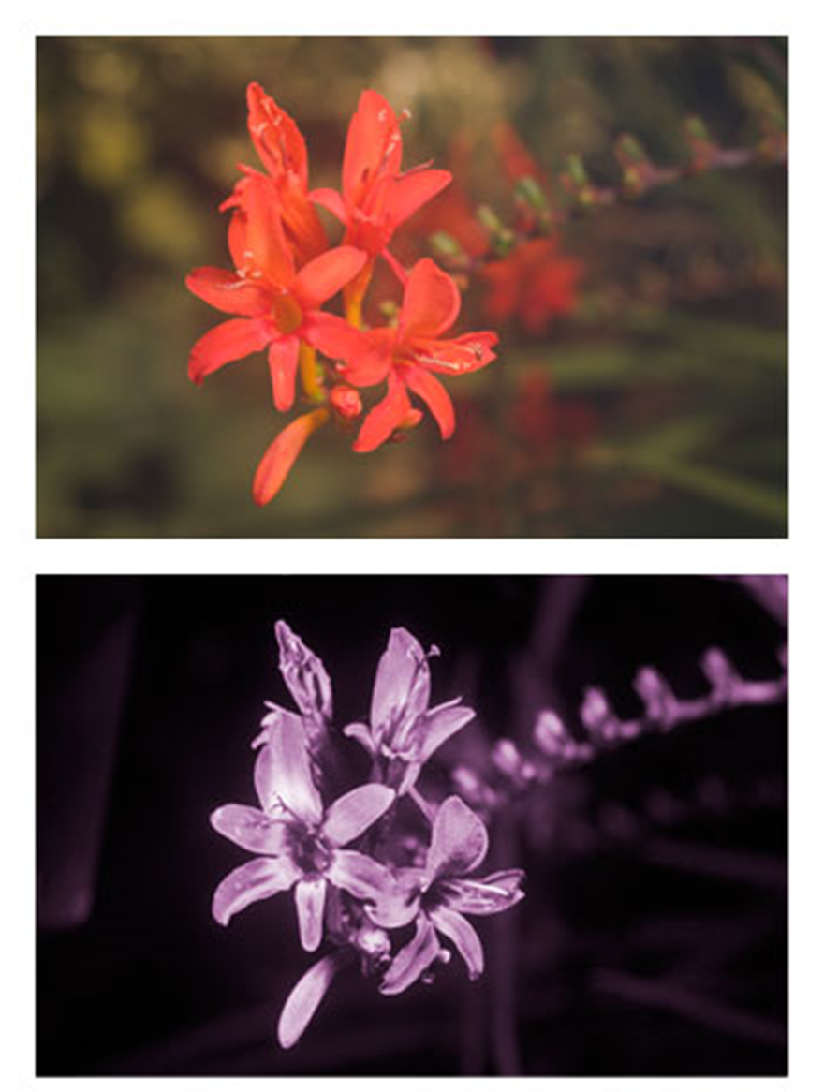

Directions for Craft 2: Bee Anatomy

**Supplies for 12 Youth**

* 3 egg cartons (paper is best)
* Green, yellow, orange, and back markers
* 30 black pipe cleaners
* 20 yellow pipe cleaners
* 24 googly eyes
* Wax paper
* Scissors
* Glue

**Directions**

1. Ahead of time, cut egg cartons so you have twelve pieces of three and cut 12 pieces of wax paper. You may wish to show them a diagram of a bee body like the one below (all legs are attached at the thorax, a little difficult to tell from the diagram).
2. Give each youth a piece of egg carton, a piece of wax paper, some markers, and tell them to choose one of the bees they have learned about.
3. Have them color the egg carton to look like the body of that bee. Tell them to make one section the head, the middle section the thorax, and the third section the abdomen.
4. They can glue eyes and pipe cleaners for antennae on the head.
5. They can cut wings out of wax paper: a bee has four wings, two on each side.
6. A bee has six legs. Have youth choose the right color of pipe cleaner and cut some legs.
7. Wings and legs can be glued on to the middle section, the thorax.
8. They now have a model of a bee with all the right parts.

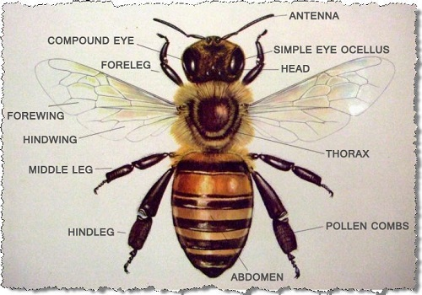

Directions for Craft 3: Bee Origami

**Supplies for 12 Youth:**

6 pieces of origami paper

**Directions:**

Have youth follow the directions from this website: <https://www.origami-resource-center.com/easy-origami-bee.html>

You may want to print copies of the directions for the youth to use and/or make a model to show what they should look like.

You may want to cut the origami paper in half, as directed, ahead of time. Paper colors of yellow, orange, green, and black would be best. These reflect the colors of the native bee species in the program.